World-wide developments with gapminder
JHvdZwan
AP statistics; worksheet WS20220511
Names:

Got to this webpage.
What you see looks like this.
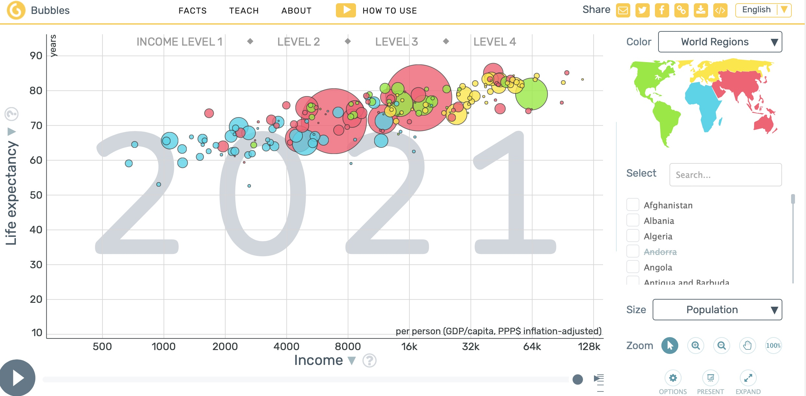
In the upper left corner, click on ‘Bubbles’ and choose ‘Trends’.
What you see is a graph with Time in Years on the x-axis and Income per person in USD (on a log scale) on the y-axis.
If you click on the arrow in the lower left corner, you will see the evolution of the Variable on the Y-axis over time.
Exercise 1
Experiment a bit with the possibilities for graphing trends.
Exercise 2
On the Y-axis choose Income per person (the deafault).
On the right hand side, choose Jordan, the United States, South Korea, Haiti and Bangladesh and, if you like, another country of your interest.
- In which year did Income per person in South Korea cross Income per person in Jordan?

- Which of the selected countries has the steepest slope in the Income graph since 1960?

- Which of the selected countries has the flattest slope in the Income graph since 1960?

Exercise 3
In the upper left corner choose ‘Ranks’.
Choose in the upper left corner under Ranks on Population Totals and choose CO2 emissions per person.
Choose Color (upper rigth) for World regions.
- In which World Region are the countries with highest levels of CO2 emission per person in 2021 located

- In which World Region are the countries with lowest levels of CO2 emission per person in 2021 located?

Choose Child Mortality instead of CO2 emission.
- How is Child Mortality measured?

- What stands out if you examine the ranking of the countries?

(v) Choose a variable of your interest instead of Child Mortality.
Variable:
How is this variable measured:

(vi) What stands out if you examine the ranking of the countries for this variable?

