World-wide developments with gapminder
JHvdZwan
AP statistics; worksheet WS20220510
Names:

Got to this webpage.
What you see looks like this.
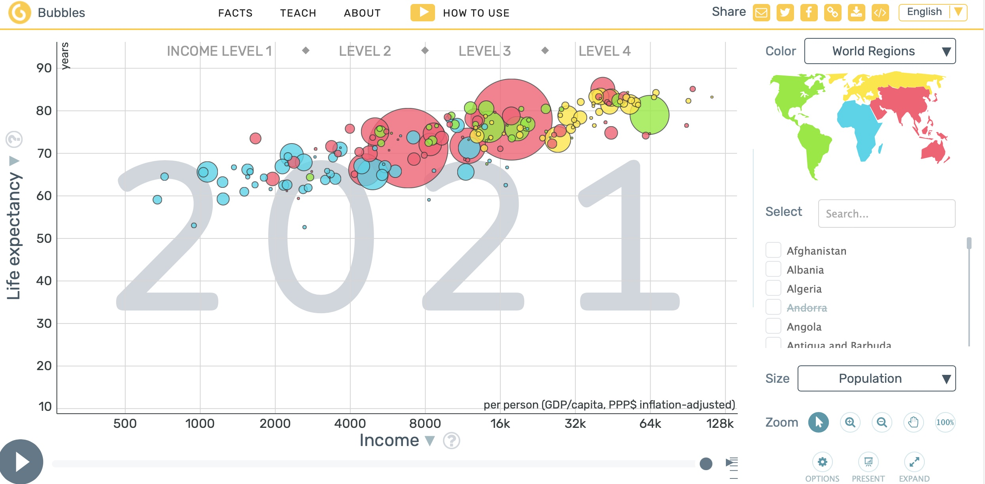

What you see is a graph with on the x-axis the income per person in USD (on a log scale) and on the y-axis Life expectancy by birth.
Every bubble is a country; the area of a bubble represents the population size.
If you click on the arrow in the lower left corner, you will see the evolution of Life Expectancy vs. Income from 1800.
If you point the mouse at a bubble, the name of the country is displayed.
Note that the graph display a variety of variables in one graph:
- Income is mapped on the X-axis
- Life-Expectancy is mapped on the Y-axis
- Population Size is mapped on the area of the bubbles
- The continent where the country is located is mapped on the color of the bubble
- Time variable is added by using video technique
The website offers a variety of options to visualize world-wide developments. On the right hand side you can choose the countries you want to be displayed in the graph and at the axis you can choose which variables to display at the y- and x-axis.
On the right hand side you can adjust a couple of settings with the Trails-button and using the Options-button.
Exercise 1
Experiment a bit with the possibilities for graphing variables.
Exercise 2
On the right hand side, choose Jordan, the United States, South Korea and one or more other countries of your interest.
Plot Life Expectancy on the Y-axis and Income on the X-axis.
- Compare Jordan with the USA. What stands out?

- What stands out if you compare the development of South-Korea with the USA?

- What stands out about the country (or countries) of your choice?

Exercise 3
Map ‘CO2 Emmission per person’ on the Y-axis.
Map ‘Income’ on the X-axis.
Map ‘World Regions’ on Color.
Map Population on Size.
- Is there a relationship between World Region and CO2 Emission.

- What stands out when you look at this graph; name at least two things.

