Chi-Square Tests for Two-Way Tables
JHvdZwan
03/27/2022
Worksheet WS20220327

Inference for Linear Regression
Simple Ordinary Least Square (OLS) Linear Regression Models are theoretical models based on the assumption that the relationship between two quantitative variables, a response (or dependent) variable Y and an explanatory (or independent) variable X, can be described by: $μ_{Y}$ = $α$ + $β$X.
The model says that for different X-values, we have different expected (mean) Y-values; the relationship between these expected Y-values and the associated X-values is linear in this model.
More in depth, the model states that:
Y = $α$ + $β$X + $ϵ$
where, $ϵ$ (epsilon) is a random variable with mean value 0 and standard deviation $σ_{ϵ}$. The model assumes that $ϵ$ is normally distributed with mean 0 and standard deviation the same for all X-values.
Figure 1
Example Scatter Plot with Theoretical Regression Model
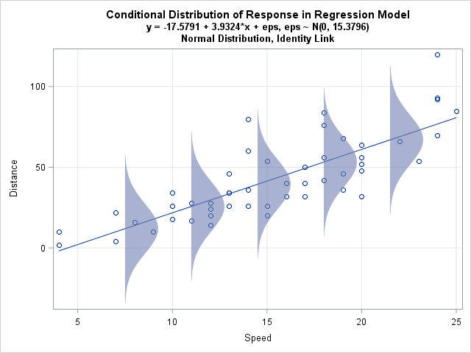
Note. Compare Figure 12.6, p. 742 of the textbook.
When a OLS regression model is applied, a sample is used to estimate the values of $α$, $β$ and $σ_{ϵ}$.
The estimates for $α$ and $β$ are calculated based on the Least Squares criterion. This criterion chooses as best fitted line, the line for which the sum of the squared differences between Y-values and predicted Y-values is minimal.
Figure 2
Illustration OLS criterion
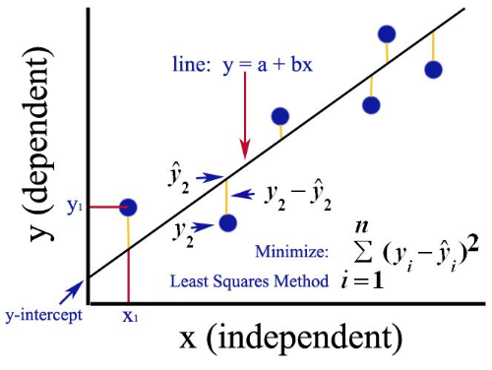
The criterion is unambiguous, there is only one OLS regression line that fits the sample data best.
Example
In this example we draw a sample (n=40) from a website (www.jaap.nl) with information of houses for sale in Utrecht, a Dutch city, on a certain date. Total number of houses for sale in Utrecht on the website is 490.
The objects in the dataset are houses for sale. The variables in the dataset are:
- CITY, the name of the city where hte house for sale is located
- POSTCODE, the first four characters of the Dutch postcode
- ROOMS, the number of rooms
- AREA, the area in $m^{2}$
- PRICE, the asking price in euro
Table 1
First Five Objects of Sample Data
CITY | POSTCODE | ROOMS | AREA | PRICE | logAREA | logPRICE
Utrecht | 3524 VD | 7 | 150 | 389,000 | 5.0 | 13
Utrecht | 3532 SL | 3 | 79 | 289,000 | 4.4 | 13
Utrecht | 3553 VS | 2 | 22 | 89,000 | 3.1 | 11
Utrecht | 3572 RK | 4 | 114 | 450,000 | 4.7 | 13
Utrecht | 3553 EC | 3 | 80 | 275,000 | 4.4 | 13
The whole sample can be found on Google Classroom in a Google Sheets file named sample_ut.
Exercise 1
- Open the sample_ut file in Google Sheets.
- We are interested in the relation ship between AREA and PRICE.
Which of the two is the Response Variable (Dependent or Y-Variable) and which is the Explanatory Variable (Independent or X-variable)?
Response Variable: Explanatory Variable:
- To check whether a Linear Model is applicable, first draw a appropriate graph in Google Sheets to check the linearity of the relationship. Comment on what you see in the graph.

- Double click on the graph, the Chart Editor pops up. Choose ‘Customize’ and scroll down to ‘Series’; select the check box ‘Trendline’, in the ‘Label’ field choose ‘Use Equation’ and select the check box ‘Show R²’
What is the value of R² and give an interpretation for this value.

- What is the equation of the OLS regression line?

- What is the slope of the OLS regression line and give an interpretation for this value.

- What is the intercept of the OLS regression line? Is this intercept value meaningful in this context?

Exercise 2 On the second tab of the sample_ut file, you find another random sample from the same website on the same day and for the same city.
- Draw a scatter plot (PRICE versus AREA) for this data set, add the trendline and the R² value.
- What is the slope of the OLS regression line based on this sample? And what is the value of R²?

- How comes that the values in part (ii) differ from the values for the slope and R² in exercise 1?

Exercise 3
Return to the sample used in exercise 1.
Investigate whether the relationship between the number of rooms and the the area of the house can be described with an OLS regression model. First think about which variable to choose as responsive variable.

Exercise 4
Return to the sample used in exercise 1.
Investigate whether the relationship between the number of rooms and the price can be described with an OLS regression model.

Inference for Regression (continued)
As is the case with estimating a mean value, different samples lead to different estimates for the slope in an OLS regression model. Or, in other words, we deal with a sample statistic with its own sampling distribution and face the problem of sample variation.

Estimating the Regression Coefficient $β$ in OLS Linear Regression
Let us focus on the slope of the regression line, $β$.
In Chapter 3 you learned to estimate the equation of a regression line based on sample data. In other words, you learned to calculate point estimates for the intercept $α$ and for the slope $β$. These point estimates are denoted as a and b (a common practice in Statistics is to use Greek letters for model parameters and Latin letters for estimates).
For different reasons, when analyzing the relationship between two variables, the value of $β$ is more interesting than the value of $α$:
- in many cases the intercept is outside the range of observed values
- the slope $β$ informs us about the expected change of the Y-value given an one unit change of the X-value, so it is useful in an association analysis
In the example below we examine the variability in the estimates for $β$ when using different samples from the same population in order to construct an interval estimate for $β$ instead of only a point estimate.
Example
Compare Exercises (1) and (2) above. In this example we draw samples from a dataset with information of houses for sale in a Utrecht, a Dutch city, on a certain date. The objects in the dataset are houses for sale. The variables in the dataset are (cf Table 1 above):
- CITY, the name of the city where hte house for sale is located
- POSTCODE, the first four characters of the Dutch postcode
- ROOMS, the number of rooms
- AREA, the area in $m^{2}$
- PRICE, the asking price in euro
As was the case with estimating mean values, we are interested in the variability in the estimates for the slope, in other words we are interested in the standard error of the sampling distribution of the b statistic.
One way to get an idea about the variation in the estimates for the slope is (simulate) drawing samples from a population.
In this case a data set from the population, all houses for sale on Jaap.nl on the specific, is available.
We used R to draw 1000 samples from this data set, all with n = 40.
For each sample, an OLS regression analysis is performed. This leads to 1000 estimates for the slope $β$ of the regression model (and of course also to 1000 estimates for other sample characteristics like the intercept and R², but for now we focus on the slope). These 1000 estimates give insight in the variability of the b statistic.
Model 1
Example of R output OLS Regression Model
##
## Call:
## lm(formula = PRICE ~ AREA, data = re_samples[[1]])
##
## Residuals:
## Min 1Q Median 3Q Max
## -232816 -68651 -24218 102257 272432
##
## Coefficients:
## Estimate Std. Error t value Pr(>|t|)
## (Intercept) -81173.1 39526.5 -2.054 0.0469 *
## AREA 4820.6 310.9 15.508 <2e-16 ***
## ---
## Signif. codes: 0 '***' 0.001 '**' 0.01 '*' 0.05 '.' 0.1 ' ' 1
##
## Residual standard error: 118300 on 38 degrees of freedom
## Multiple R-squared: 0.8635, Adjusted R-squared: 0.86
## F-statistic: 240.5 on 1 and 38 DF, p-value: < 2.2e-16
Figure 3
Distribution of 1000 estimates for b statistic
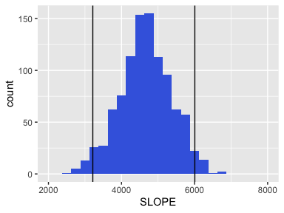
The mean value of the 1000 slope sample values is 4662.
The SD of the 1000 slope sample values is 703.3.
The distribution of the 1000 slope values can be used to construct a CI for the value of $β$, the ‘real’ slope of the population regression line. For instance for a 95% CI the .025 and the .975 quantiles are used as the borders, CI_{0.95} = <3214; 6006>; see vertical lines in the graph.
Above we draw 1000 samples from the population database. But normally we only have one sample and the population database is not available.
A contemporary way to solve this is bootstrapping: simulate drawing samples with replacement from the one sample you have, with the same sample size as your original sample. Below we have used 1000 bootstrap samples to estimate the standard error of b, the estimate of the slope of the regression line.
Figure 4
Distribution of 1000 bootstrap estimates for b statistic
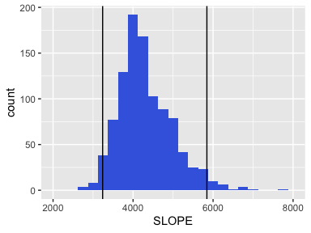
The mean value of the 1000 slope sample values is 4315.
The SD of the 1000 slope sample values is 669.3.
The distribution of the 1000 bootstrap slope values can also be used to construct a CI for the value of $β$, the ‘real’ slope of the population regression line: CI_{0.95} = <3240; 5845>. This leads to a (slight) different CI from the CI constructed based on 1000 samples from the population data.

Theoretical Distribution of the OLS Regression Slope
The above constructed distributions for b are approximations for the Sampling Distribution of b. From theory about inference it is known that (see p.741):
- Center. The mean of the sampling distribution of b is $μ_{b}$ = $β$.
- Spread. If the 10% condition is satisfied, the standard deviation of the sampling distribution of b is $σ_{b}=\frac{σ}{σ_{x}\sqrt{n}}$
- Shape. The sampling distribution of b is approximately Normal if the values of the Y-variable follow a Normal distributtion for each value of X (normal condition)
Based on these assumptions, computer output from an OLS regression reports, among other values, an estimate b for the slope $β$ of the regression line and also an estimate for the SD of the sampling distribution of b. See for instance the output below.

Model 2
Example of R output OLS Regression Model
##
## Call:
## lm(formula = PRICE ~ AREA, data = bootstrap_samples[[1]])
##
## Residuals:
## Min 1Q Median 3Q Max
## -202511 -70403 -48301 58470 695160
##
## Coefficients:
## Estimate Std. Error t value Pr(>|t|)
## (Intercept) -47180.1 61828.2 -0.763 0.45
## AREA 4005.7 504.1 7.946 1.34e-09 ***
## ---
## Signif. codes: 0 '***' 0.001 '**' 0.01 '*' 0.05 '.' 0.1 ' ' 1
##
## Residual standard error: 148700 on 38 degrees of freedom
## Multiple R-squared: 0.6243, Adjusted R-squared: 0.6144
## F-statistic: 63.13 on 1 and 38 DF, p-value: 1.343e-09
Exercise 5
- What is the equation for the OLS regression line in Model 2?

- What is, according to the output in Model 2, the SE of the b values?

- What is, according to the output in Model 2, the R² value?

- Compare the different estimates for b and for the standard error of b.

- Construct a 95% CI for b based on the output in Model 2, using the formula on p. 747 of the textbook (in this case the degrees of freedom for the t-value is n-2, see p. 748).

That the estimates in exercise 5 differ, has to do with the use of different samples and also with the conditions for using the theory. That is why it is important to check the conditions before performing Regression Inference, e.g. constructing a CI for $β$. See pp. 742-745.
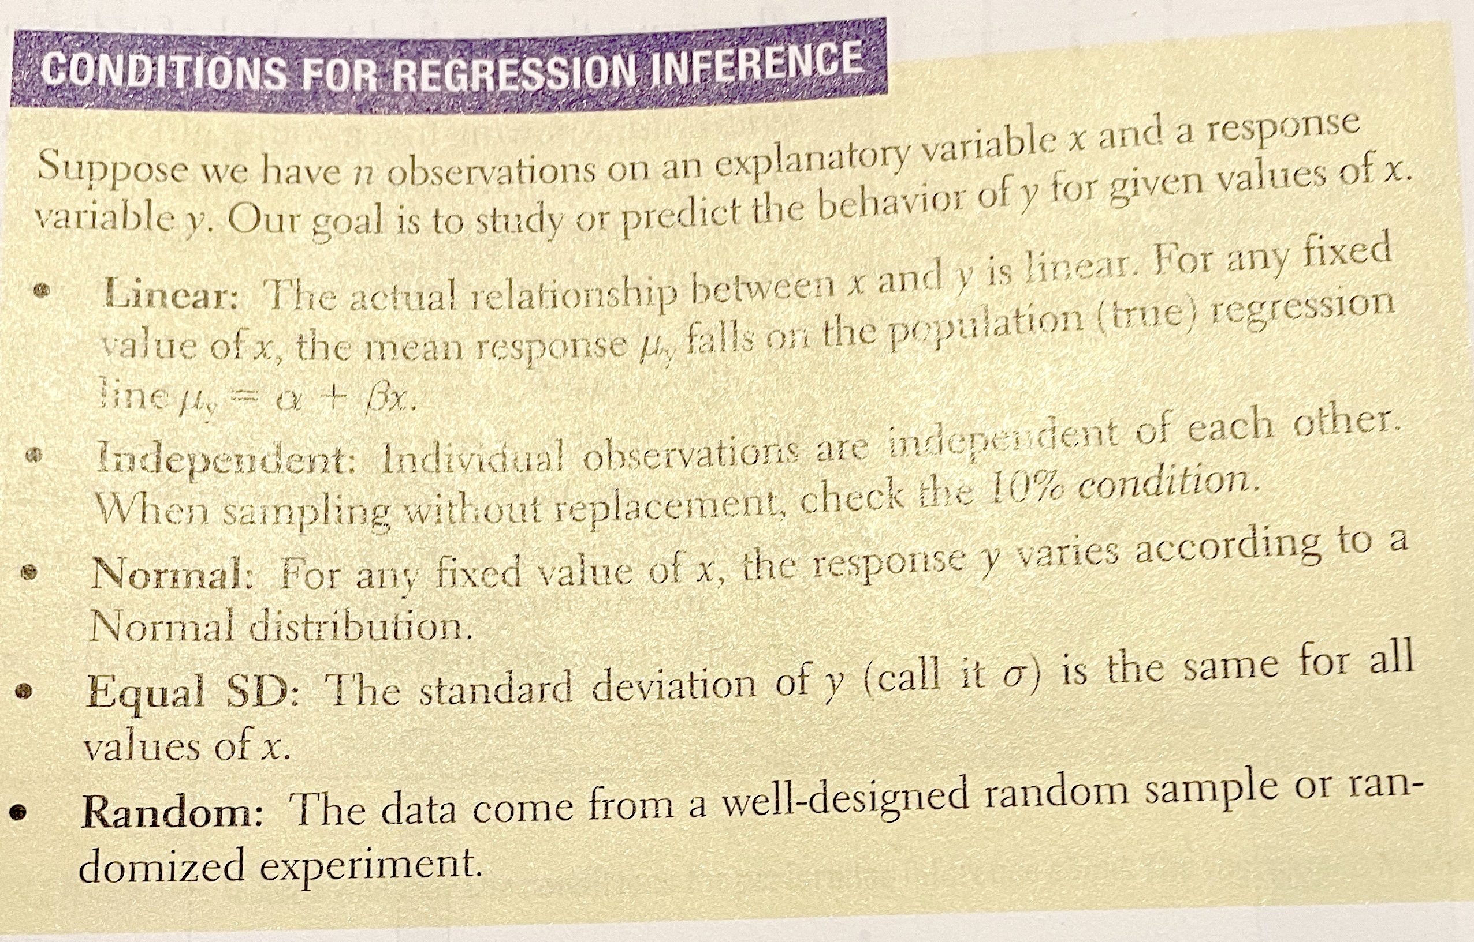
Study carefully pp. 743-745 about checking the conditions and the example on pp. 745-746.
Make Exercises 12.1, 12.2, 12.3, 12.5

Conditions Check for Regression Inference
See pp.743-744 in the textbook.
We return to the example about house prices in Utrecht and perform a Conditions Check for Regression Inference. In such Condition Checks, graphs play an important role.
Step 1 Linearity Check
To check the applicability of an OLS regression model, we plot:
- a scatter plot, Y versus X
- a residual scatter plot, Residuals versus X
Exercise 6
In exercise 1 we already plot Y versus X in a scatter plot.
- Linearity. Is the overall pattern in this plot roughly linear?
To draw a satter plot Residuals versus X, we first have to calculate the model value $\hat{Y}$ and the residuals, Y-$\hat{Y}$, for each observation.
- Go to the spreadsheet with the sample data in Google Sheets. Add a column with fitted values and a column with Residuals.
- Create a scatter plot Residuals versus X values.
- Do the residuals seem to center on the “residual = 0” line at each X-value in the residual plot? Or is there a pattern visible in this plot.

- Independent. Check the independent condition (see text book).

- Normality Residuals. Use a plot to check if there is good reason to doubt the normality of the distributions of the Residuals.
NB. Best choice is a Normal Probability plot.

- Equal SD or Homoscedasticity. Use the Residuals versus X scatter plot. Check whether the spread of the residuals is roughly the same from the largest to the highest X-value.

- Random. The data come from a Random Sample from all houses for sale in Utrecht on the specific date. Nothing to check here.
Figure 5
Scatter Plot Sample Data Houses for Sale in Utrecht om yyyy-mm-dd
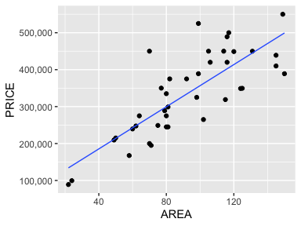
Figure 6
Scatter Plot RESIDUALS versus AREA
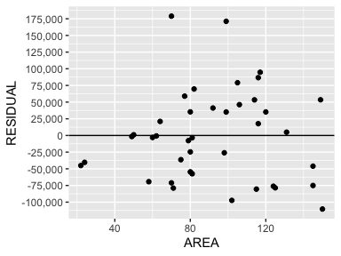
Figure 7
Density Plot Residuals
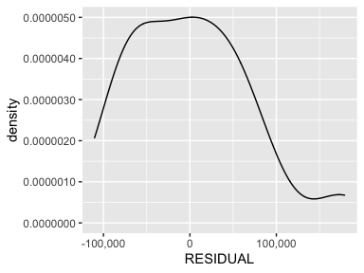
Figure 8
Normal Probability Plot Residuals
